This is where you can tell everyone about the team you are on. You can tell them what you have done so far as a team and how many members are on your team. You can also talk about the trip you will be on. Include where you are going and that you are going as an ORU student through the ORU Missions & Outreach office. You could mention ORU’s focus on making a strategic short-term investment into God’s long-term Kingdom work, which is the work that your contacts have already been a part of. Tell everyone about what you will be doing on the trip, the dates of your trip, and the necessary funds you will need to raise to travel on the trip.

Invite others to follow you throughout your fundraising and mission trip adventure. This allows your supporters to see what you are doing and how they can help you and stay in touch even after you send out your letter/brochure.

My Team

Contact Information





Add your Facebook name or the name of a Facebook group they can follow

Put your Twitter handle here and tweet updates about your trip.

[https://encrypted-tbn1.gstatic.com/images?q=tbn:ANd9GcR7stwQTkVoPZVRpBZKS1W2aHzSqAPEX7T9KKHvXi6kVYE5_RWHtQ](http://www.google.com/url?sa=i&rct=j&q=&esrc=s&frm=1&source=images&cd=&cad=rja&uact=8&docid=98GtSs06mtcMZM&tbnid=nZDhQyM6iq7URM:&ved=0CAcQjRw&url=http://ms442.org/&ei=y3AsVJL0LsKBygSgxYII&bvm=bv.76477589,d.aWw&psig=AFQjCNGgJTFsxwppN4gvNjKh_M9MJS9qLA&ust=1412284956102018)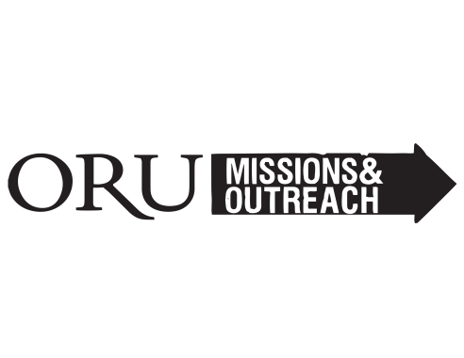

You could place a picture of your destination here.

You can add a caption for your photo here!

Put your Instagram handle here and post pics of your team or your fundraising efforts

If you put down your name or handle for social media make sure you remember to post about your trip. Give your supporters updates and praise reports so they can stay in touch with you and your trip! Social media is one of the strongest ways to communicate with donors and supporters as technology is a main focus of our day-to-day lives. People love to see your updates through social media on their phones and computers.

ORU MISSIONS

7777 S. LEWIS AVE.

TULSA, OK 74171

ORUMISSIONS.COM

918-495-7728

MISSIONSOUTREACH@ORU.EDU

.

Jonny Appleseed

South Africa

May 13th - JUNE 12th

Here you can write more about your destination. You could write briefly about what you expect the trip to be like. You could also add interesting facts about wherever you are going to make your brochure interesting to the people you send it out to.

Trip Details

**TRIP DATES**

Spring Break: *March 17th – 25th*

2 Weeks: *May 13th – 29th*

1 Month: *May 13th – June 12th*

**DEADLINES**

SB 50% Deadline – *January 24th*

Summer 50% Deadline - *February 14th*

SB 100% Deadline – *February 28th*

Summer 100% Deadline - *April 11th*

**FUNDRAISING AMOUNTS**

SB Domestic Total - $1,099

SB International Total - $1,799

2 Week Summer Total - $2,599

4Week Summer Total - $3,599

(Sign your name at the bottom. Type it and then hand sign it after you have printed out your letters. Also consider writing a short, personalized message at the bottom. A little extra work could go a long way!)

Here you can write about your financial goals and what your supporters can do to help you as you prepare for your trip.

* Check or money order can be mailed back in the enclosed remittance envelope.
* Credit card donations can be made online at ***ORUmissions.com/donate****.*
  + Select “On Behalf of Missionary”
  + Type “Jonny Appleseed” and “Team South Africa” in box below

Remember to thank them for their support!

DONATE

You can add a photo of your choice here or delete the box.

This is an opportunity to ask your supporters to pray for you. Prayer will play a huge role in your fundraising efforts, as you and your team grow together, and on the mission field. A few possible prayer points may be the following:

* Pray that our team would grow together and get to know one another better.
* Pray for our safety as we fundraise and head out onto the missions field.
* Pray for our fundraising efforts that we may see our entire team reach our financial goals.
* Pray that we are a blessing to our contacts and the people we will serve

You can add a photo of your choice here or delete the box.

Continue writing captions for the selected photos being used in your brochure.

Prayer Points

Introduction

You can put a photo of yourself here. A picture from a past missions trip would look great!

Continue writing captions for the selected photos being used in your brochure.

You can begin your brochure by sharing a little bit about what’s going on in your life. Share a testimony about what God is doing in your life or lessons you learned from your past missions trip (if you have been on one). You also might want to add a picture of yourself or even one of you with your team below this segment. The picture could be recent or a picture from a previous missions trip. This section is for you to connect with possible donors and supporters and fill them in on what’s going on in your life and how God is moving.